Steve Pokwo
Prof Choi
Writing 340
The amazing Wilshire Grand tower in Los Angeles
Wilshire Grand Tower was designed for not only commercial activities and utilitarian purposes, but also very friendly to accommodate the owner budget and also help in the speed of construction [1]. The design and the minimum space that the tower has occupied is space friendly because the space used has not utilized much of space but the building has many accommodative rooms. In Los Angeles, it is very evident that the growing markets are attracting a lot of investors who find it easier when allocating some of their business [2]. This is what the perfect solution Wilshire Grand Tower has provided to these investors. Building such as Wilshire Grand Tower are beneficial to the day to day life for Los Angeles residents and markets. For instance, the design the engineers used to build the tower is very attractive. Which is the main reason why the deterioration of Los Angeles’ economy is to the rescue? Wilshire Grand Tower mainly constitutes of hotel rooms that are comfortable and relaxed. This is due to the fact that the society is advancing and there is need for changes and innovations to the existing facilities in place. Most investors require the best and quality facilities provided through the services that are offered to them.
For many years Los Angeles has experienced complains of few hotel rooms and executive enabled rooms (shown in image 1.0, below) for a large number of investors coming to the city which negatively impacted the Los Angeles economy and that of United States. Most of the workers complained of lack of available resources like office facilities to perform their business. For this reason, the engineers and architects came into re-innovate the Wilshire Grand Hotel to the new grand tower that is now the talk and discussion in downtown. The building of the skyscraper was designed to increase the number of visitors and guests who visit Los Angeles for purposes of business and tourism [3]. The expansion of the downtown markets that is largely affected positively with the building widely increase the living standards of the people around. The downtown development is largely promoted by the engineering practices that are implemented in the area, for instance, the Wilshire Grand Tower. The 73-story building design has tremendously increased the development and attracted most of the investments downtown Los Angeles through the building of new rental homes because of the rapidly increasing population [4].
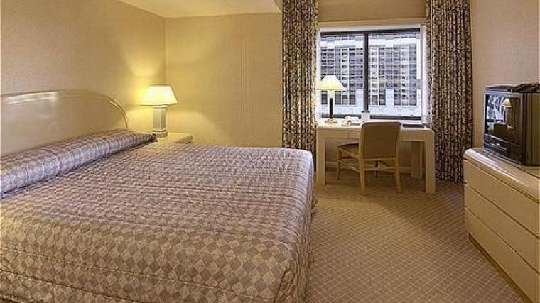
Image 1.0: Interior design (source: Google)
The elegant design that the tower has created has gave Los Angeles a new face to other cities because of the admirable feature it has pose to the future of Los Angeles. The tower is a new image of the city and it redefines the presence and essence of the downtown market. The tower has seen many of visitors who are only attracted to the look and the design of the tower. The completion of the tower is a fully the fulfillment of the promised Los Angeles to the people, a very attractive city that holds and welcome investment. Although, the investment has and rapidly growing the city also needs to focus on the need to build more rental houses that would accommodate the increasing growing population.
The rooms and offices that are provided in the tower have helped to reduce the problems experienced with office vacancy in the city as shown in image 1.0 (above). The design of the tower has greatly attracted much tourism to the city because of the unique and quality design the tower has. This to the city is a positive economic development that has seen growth to Los Angeles and the United States [5]. Furthermore, the Wilshire tower is employment definition to the city. Employment has always been a big problem in big cities like Los Angeles, the completion of the tower has seen a large number of qualified personnel being employed. The employment that the construction and the completion of the tower created has also assisted the employment problems in the city. Many are qualified in different field that can provide sustainable services but the problems that are faced in the field of seeking jobs are the obstacle to reach the dreams. The expansion of the building has seen many of the job seeker reaching the dreams of their lives [6]. This is why the work that was done by the engineers and the architects has greatly improved the lives of the people and the city. Besides bringing employment to the city, most of the engineer that had the chance to contribute to the construction of this amazing structure near the California faults are proud of their tremendous work and to the final product. For the structural and construction engineers involve to this project, it might be a lifetime career accomplishment and realization of the tallest building in the west (Shown in image 2.0, below).
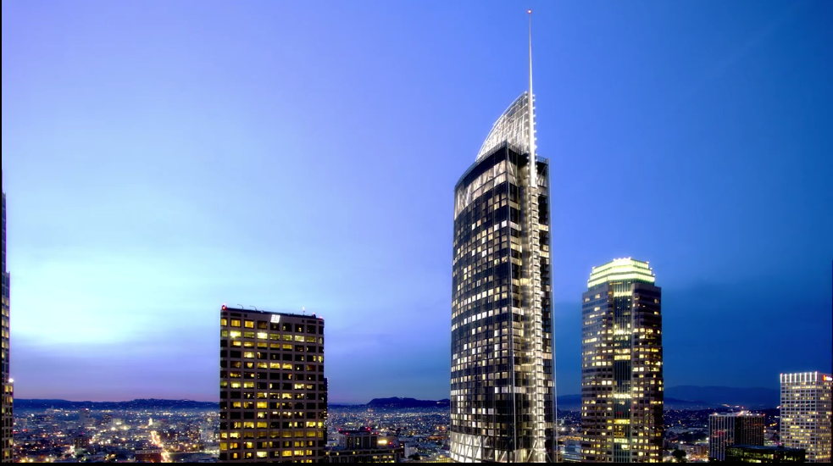
Image 2.0: Wilshire, the tallest building in L.A (Source: Google)
During the construction of the Los Angeles skyscraper, the architect and engineers had to focus on how to construct a strong building that is safe even during earthquakes. They had to come up with new ways that could provide safety during earthquake disasters and ensure the building was not prone to coming down. The architect had to focus on some innovative solutions that could help; for instance, the contractors were focused on making the core walls throughout the building. The engineers further used the green technology both internal and exterior which was demolished from the old Wilshire to provide the combined steel and concrete materials that were recycled from the materials [7]. Being tall the engineer's focus was to make the building strong that could accommodate the Santa Ana winds and the ground movements during earthquakes. The building is designed to use high and quality energy and climate systems that are sufficient to serve the whole building [8]. The energy and climate systems are used on every floor to provide enough support. In addition, the engineers had to focus on the highly improved and innovated lighting systems throughout the building with thick glasses walls. The specific weight that the building had to be concentrated on to ensure the building was not prone to any casualty.
Being at the executive level, the engineers had to think about innovated ways that can accommodate the executive members who are the clients for instance; the engineers came up and design of about 760 prefabricated bathrooms for the project [9], this innovation really help with the schedule and the location of the building in the heart of the busy downtown Los Angeles. The quality of finishes was also appropriate and accommodate to the high class tourists and travelers who are visiting Los Angeles for different purposes. Focusing on the height and the weight the engineers had to ensure proper coordination during the tiresome work of pouring more than 20000 cubic yards of concrete. This performance helped the project win the Guinness Record for continuously concrete pour [10] (image 3 below).
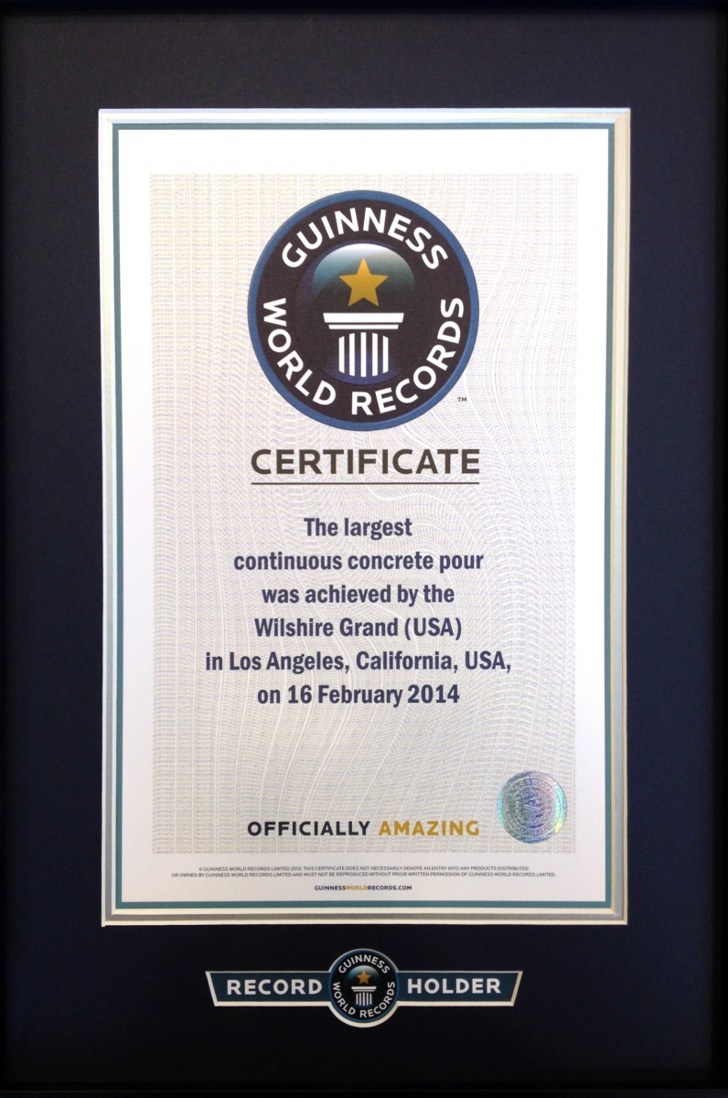
Image 3.0: Wilshire Grand, Guinness World Record (Source: Google)
For sustainable, sophisticated quality, the engineers had to coordinate to put in the 500000 square feet glasses to the lovely Los Angeles skyscraper. In addition the engineers engaged in thorough research, studies that included having the clear knowledge about the stability of the place before the start of the construction. The building has very distinctive and unique features that are very attractive. The skylight serves the gap between the tower and the next building. Although very challenging the engineers finally reached at the desired design they wanted. The designed glass ceilings give the impressing and admirable feature to between the two buildings. Skyscrapers are known for the use of elevators because of the heights. The building had to be built using advanced elevators. The engineers to create a thick and stable structure that would be accommodated in the building. The building entirely has been built by the use of glasses; the engineers used a component called rebar that has housed the elevators and the stairs. The elevators are built with a very crucial element of a concrete structure that is very strong called core.
The Wilshire Grand Tower represents an iconic structure in Los Angeles skyline today. The building will not only boost the city economy but bringing more jobs, adding more hotel rooms and offices in downtown LA and accommodate more visitors but it is also a great answer to all the seismic challenges encounter in southern California. With the ownership of Korean Air, the Architect AC Martin and the General contractor Turner Construction really collaborate efficiently and did an amazing job to make this dream come through for all Los Angeles lovers.

Reference
[1]. T. Curwen. L.A Now has a new tallest building: How it will fit into the fabric of the city is still open to debate. Los Angeles Times, (2017, June 27). Available: http://www.latimes.com/local/california/la-me-wg-essay-20170627-story.html
[2]. T. Curwen. L.A Now has a new tallest building: How it will fit into the fabric of the city is still open to debate. Los Angeles Times, (2017, June 27). Available: http://www.latimes.com/local/california/la-me-wg-essay-20170627-story.html
[3]. R. Vaillancourt. New Wilshire Grand Design Revealed. Los Angeles Downtown News online, (2013, February 7). Available: http://www.ladowntownnews.com/news/new-wilshire-grand-design-revealed/article_a1871f80-717d-11e2-aae7-001a4bcf887a.html
[4]. T. Curwen. L.A Now has a new tallest building: How it will fit into the fabric of the city is still open to debate. Los Angeles Times, (2017, June 27). Available: http://www.latimes.com/local/california/la-me-wg-essay-20170627-story.html
[5]. Wilshire Grand center. Wilshire Grand Design, 2012. Available: http://www.wilshiregrandcenter.com/design
[6]. T. Curwen. L.A Now has a new tallest building: How it will fit into the fabric of the city is still open to debate. Los Angeles Times, (2017, June 27). Available: http://www.latimes.com/local/california/la-me-wg-essay-20170627-story.html
[7] Wilshire Grand center. Wilshire Grand Design, 2012. Available: http://www.wilshiregrandcenter.com/design
[8]. Wilshire Grand center. Wilshire Grand Design, 2012. Available: http://www.wilshiregrandcenter.com/design
[9] Wilshire Grand Los Angeles, CA, 2015. Available: https://oldcastlesurepods.com/portfolio/wilshire-grand-los-angeles-ca/
[10] Wilshire Grand Sets Guinness World Record, (2014, February 16) http://www.ladowntownnews.com/news/wilshire-grand-project-sets-guinness-world-record/article_e01ecdf2-976e-11e3-99c8-0019bb2963f4.html

